Ex. No. 3 | SIMULATION OF MACROPROCESSOR
AIM
To write a program to simulate the functions of a macroprocessor.
DESCRIPTION
A macroinstruction is a notational convenience for the programmer. It allows the programmer to write shorthand version of a program (module programming). The macro processor replaces each macro invocation with the corresponding sequence of statements (expanding)
Macro Processor
- Recognize macro definitions
- Save the macro definition
- Recognize macro calls
- Expand macro calls
ALGORITHM
1. Get the C program, which include the macro definition.
2. Expand the macro by replacing the macro call with macro body and while expanding replace the formal parameter with actual parameter.
3. Print the expanded output.
Video link:
https://youtu.be/XjVtDV-_Nvk

SAMPLE INPUT & OUTPUT
Enter the program
#define ADD(X) ( X=X/X)
#include<stdio.h>
void main()
{
int a = 10;
ADD(a);
}

The Expanded program is

#include<stdio.h>
void main()
{
int a = 10;
a=a/a; // Macro Expansion
}

QUESTION SET
- Write a program to simulate the functions of a Macroprocessor.

Program:
w=open("macro.txt","r").read()
q=g=w.splitlines()
name = []
para = []
func = []
var= {}

#used for storing and reading the definations
for line in g:
if '#define' in line:
if '(' in line:
g=line.replace('#define','').replace(' ','').replace(';','')
name.append(g[:g.find('(')])
func.append(g[g.find('{')+1:g.find('}')])
para.append(dict([(x,'')for x in g[g.find('(')+1:g.find(')')].replace(' ','').split(',')]))
print("para",para)
print("func",func)
print("name",name)

else:
g=line.replace('#define','').replace(';','').split()
var.update({g[0]:g[1]})
print(var)
else:
fn=line[:line.find('(')]
if fn in name: #checking for ADD()
for v1,v2 in zip( para[name.index(fn)], line[line.find('(')+1:line.find(')')].replace(' ','').split(',')):
para[name.index(fn)][v1]=v2
for word in func[name.index(fn)]:
if word in para[name.index(fn)]:
func[name.index(fn)]=func[name.index(fn)].replace(word,para[name.index(fn)][word])
print("\n after 1st section")
print("para",para)
print("func",func)
print("name",name)
print("var",var)

#used for substituting the values
for line in q:
if '#define' in line:
continue
else:
if line[:line.find('(')] in name:
print(func[name.index(line[:line.find('(')])])
else:
for val in var:
line=line.replace(val,var[val])
print(line)

Output:

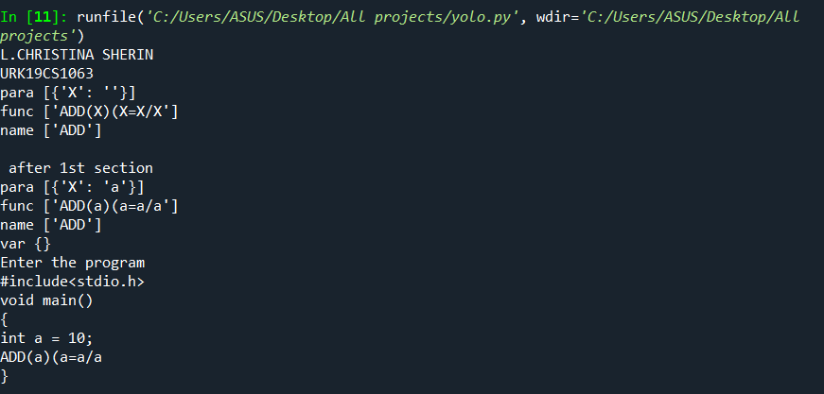

Result:
Thus the program was executed and verified successfully.

